**Tearsheet Writer’s Template (Service Offering and Solutions)**

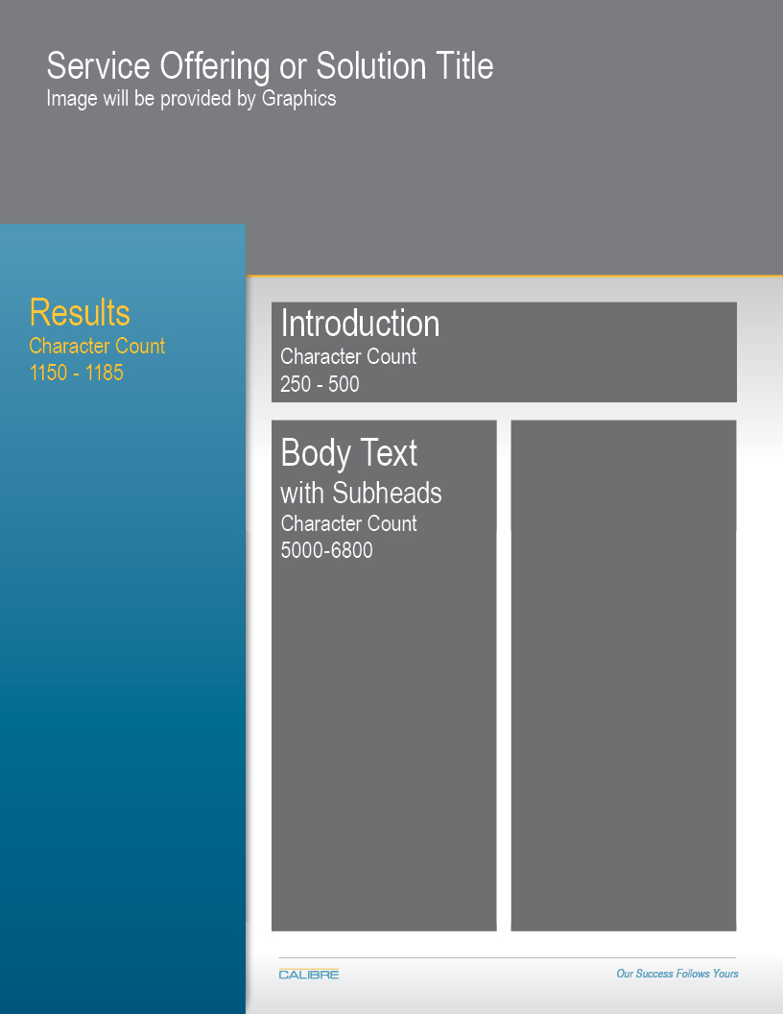

Please note the character counts for each section.

|  |  |  |  |  |
| --- | --- | --- | --- | --- |
| POC Information: | | Evan Lynch | | evan.lynch@calibresys.com |
|  | | | | |
| Service Offering orSolution Title | |  | | |
| Overview: Staff-to-Door Allocation Tool | | | | |
|  | | | | |
| Results 1150 - 1185 characters | | | | |
|  | Click here to enter text. | | | |
|  | Click here to enter text. | | | |
|  | Click here to enter text. | | | |
|  | Click here to enter text. | | | |
|  | Click here to enter text. | | | |
|  | | | | |
| Intro 250 – 300 characters | |  | | |
| Do inbound or outbound managers at your distribution center struggle to assign their people the right amount of workload throughout the day? Does every day feel like a constant fire fight due to the high volatility in carton volume? | | | | |
| Intro II 250 – 300 characters  Top performing organizations have gained a competitive edge, in large part because of their ability to harness their data to make optimal decisions. The goal with SDA is to enable operational-level managers to make optimal decisions by leveraging available data and a powerful, yet simple software solution. | | | | |
| Body Text with subheadings 5800 – 6800 characters | | |  | |
| What is SDA?   * Staff-to-Door Allocation (SDA) is a tool that enables managers to make optimal decisions when assigning staff to doors. * SDA is designed to make the job of a floor manager easier, while simultaneously enabling the productivity of staff to be maximized throughout the day.   How do I know if SDA right for my distribution center?  SDA is most valuable for facilities that meet the following criteria:   1. Interest   There is an interest in optimizing the allocation of scarce resources   1. Decision Complexity   Managers needs to make complex resource allocation decisions very quickly with several, sometimes thousands, of available options. Factors that affect the complexity of the decision process include:   * + Size of the facility   + Number of cartons routed through the facility in a typical day   + Level of volatility observed in carton flow throughout the facility over time   + Number of staff, average number of doors per staff member, and average number of staff per manager  1. Data Quality   The number of cartons that will be routed to a door is known before staff allocation decisions need to be made, or can at least be modeled/predicted. If neither is possible, SDA can still be used as a benchmarking tool, comparing actuals to ideal state | | | | |
|  | | | | |